Anchor Point

📘 Definition
# Source: AI Source: Provided by: [Data Path: Persons Table -> ID Column: 1, Name_En Column: Motasem Essam] -> From: [ChatGPT] on [5/2/2026]
An anchor point is a fixed reference point in a shape or object used in computer graphics to control its position, rotation, and scaling.
It acts like a handle or center point that other transformations depend on.

🧭 How anchor points work
# Source: AI Source: Provided by: [Data Path: Persons Table -> ID Column: 1, Name_En Column: Motasem Essam] -> From: [ChatGPT] on [5/2/2026]
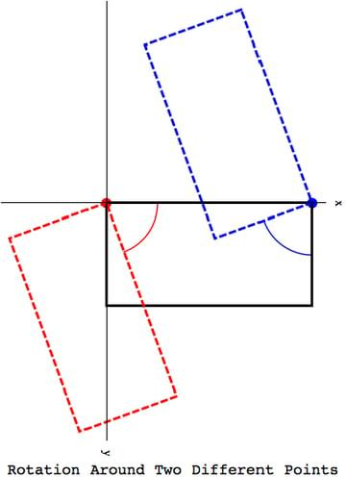
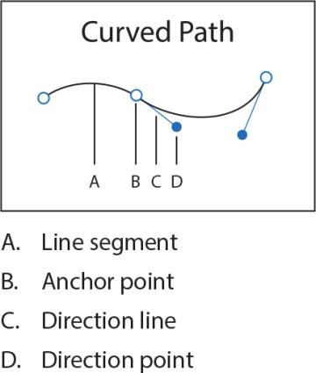
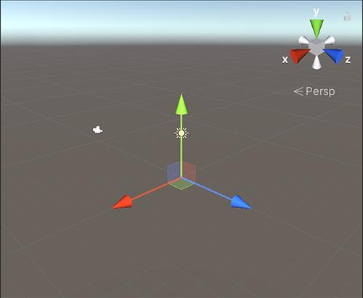
- Every object has a reference point (anchor/pivot)
- When you move, rotate, or scale an object, it happens around this point
- Changing the anchor point changes how the object behaves

🧠 Simple example
# Source: AI Source: Provided by: [Data Path: Persons Table -> ID Column: 1, Name_En Column: Motasem Essam] -> From: [ChatGPT] on [5/2/2026]
Think of:
- 🚪 A door hinge → the door rotates around the hinge
- 🎡 A Ferris wheel center → everything rotates around the middle
- 🖼️ An image → resizing can happen from its center or corner
The hinge or center is the anchor point.

🎮 Where anchor points are used
# Source: AI Source: Provided by: [Data Path: Persons Table -> ID Column: 1, Name_En Column: Motasem Essam] -> From: [ChatGPT] on [5/2/2026]
- 🎬 Animation (rotating characters or objects)
- 🎨 Graphic design (logos, shapes)
- 🧑‍💻 UI design (buttons and icons scaling)
- 🎮 Game development (object movement and rotation)

⚙️ Key features
# Source: AI Source: Provided by: [Data Path: Persons Table -> ID Column: 1, Name_En Column: Motasem Essam] -> From: [ChatGPT] on [5/2/2026]
- 📍 Acts as a fixed reference position
- 🔄 Controls rotation and scaling behavior
- 🎯 Can be moved or adjusted
- 🧩 Important for animations and transformations

🚀 In short:
# Source: AI Source: Provided by: [Data Path: Persons Table -> ID Column: 1, Name_En Column: Motasem Essam] -> From: [ChatGPT] on [5/2/2026]
Anchor Point = a fixed point in an object around which movement, rotation, and scaling happen.

